Iris Flower Species Classification Using Machine Learning
A supervised classification project using scikit-learn

1. Objective
This project builds and evaluates machine learning models that classify Iris flowers into one of three species — Iris setosa, Iris versicolor, and Iris virginica — based on four measurements: sepal length, sepal width, petal length, and petal width.

2. Dataset
The classic Fisher/Anderson Iris dataset (1936) is used. It contains 150 samples, 50 from each species, with four numeric features per sample. The dataset is loaded directly from scikit-learn's built-in datasets module (sklearn.datasets.load_iris), so no manual download or external file is required.
- Samples: 150 (50 per species)
- Features: sepal length, sepal width, petal length, petal width (all in cm)
- Target classes: setosa, versicolor, virginica

3. Methodology
The workflow follows standard supervised-learning practice:
- Load the dataset and inspect its structure and class balance.
- Split data into 80% training and 20% testing sets, stratified by species.
- Scale features using StandardScaler (helps distance/margin-based models).
- Train four different classifiers: K-Nearest Neighbors, Decision Tree, Random Forest, and Support Vector Machine.
- Evaluate each model on the held-out test set using accuracy, precision, recall, and F1-score.
- Select the best-performing model and visualize its confusion matrix.
- Use the trained model to predict the species of a new, unseen sample.

4. Results — Model Comparison
The table below summarizes test-set accuracy for each model:
Model | Accuracy | Notes
Support Vector Machine (linear) | 100.00% | Best performer on this split
K-Nearest Neighbors (k=5) | 93.33% | Slight confusion on versicolor/virginica
Decision Tree | 93.33% | Simple, interpretable, prone to overfitting
Random Forest (100 trees) | 90.00% | Ensemble of trees, slightly lower here

5. Best Model — Detailed Report
The Support Vector Machine (linear kernel) achieved the highest accuracy (100%) on the test set. Its per-class performance:
Species | Precision | Recall | F1-score | Support
setosa | 1.00 | 1.00 | 1.00 | 10
versicolor | 1.00 | 1.00 | 1.00 | 10
virginica | 1.00 | 1.00 | 1.00 | 10

6. Visualizations
Confusion matrix for the best-performing model (SVM):
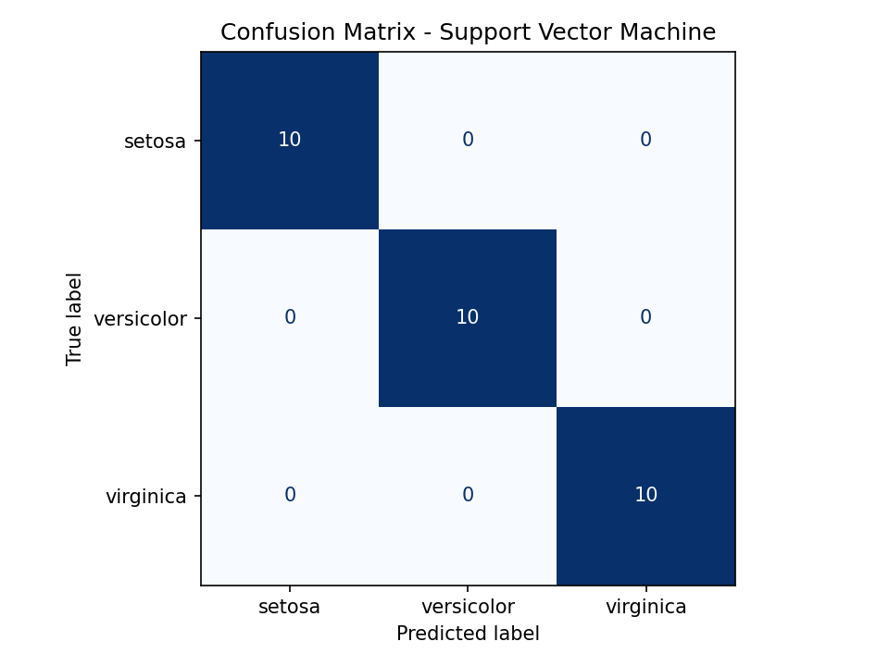

Accuracy comparison across all four models:
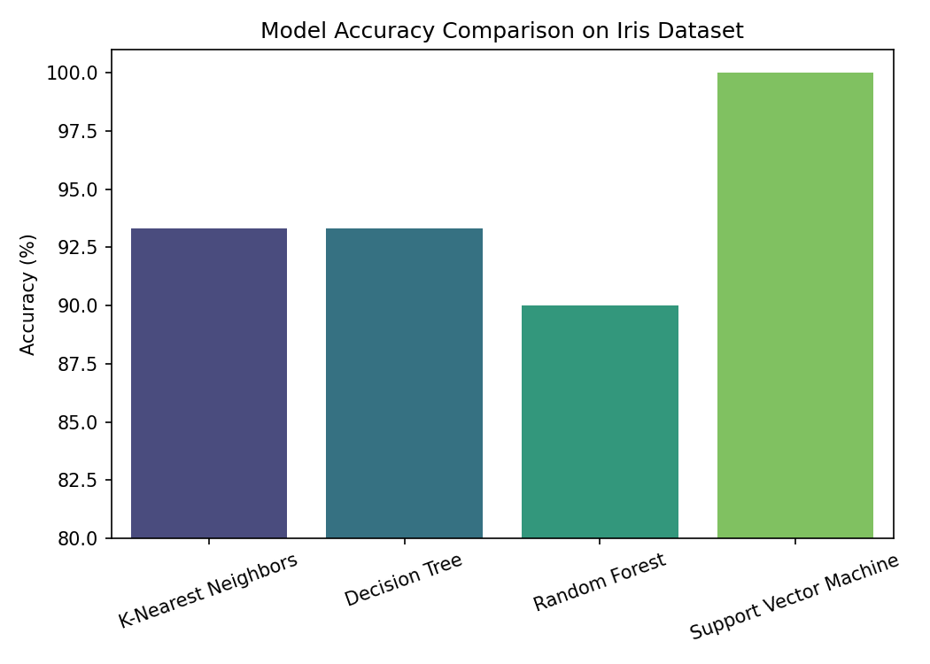

7. Prediction on a New Sample
Using the trained SVM model, a new, previously unseen flower with measurements [sepal length = 5.9, sepal width = 3.0, petal length = 5.1, petal width = 1.8] was classified as: Iris virginica.

8. Conclusion
All four models achieved 90% or higher accuracy, confirming that the Iris dataset's classes are largely linearly separable, with only minor overlap between versicolor and virginica. The Support Vector Machine performed best on this particular train/test split. This project demonstrates the core supervised-learning workflow: loading data, splitting it, training multiple models, evaluating them with standard metrics, and using the best model for prediction.

Appendix: Full Python Source Code
"""
Iris Flower Classification using Machine Learning
====================================================
Dataset : Fisher's Iris Data Set (Iris setosa, Iris versicolor, Iris virginica)
Goal : Train a classifier to predict species from 4 flower measurements
(sepal length, sepal width, petal length, petal width) and
evaluate its accuracy/performance on unseen test data.

Library used: scikit-learn (dataset is built directly into sklearn,
no manual download needed).
"""

import pandas as pd
import numpy as np
import matplotlib.pyplot as plt
import seaborn as sns

from sklearn.datasets import load_iris
from sklearn.model_selection import train_test_split
from sklearn.preprocessing import StandardScaler
from sklearn.neighbors import KNeighborsClassifier
from sklearn.tree import DecisionTreeClassifier
from sklearn.ensemble import RandomForestClassifier
from sklearn.svm import SVC
from sklearn.metrics import (
accuracy_score,
classification_report,
confusion_matrix,
ConfusionMatrixDisplay,
)

# ---------------------------------------------------------
# 1. LOAD THE DATASET
# ---------------------------------------------------------
iris = load_iris()
X = iris.data # features: sepal/petal length & width
y = iris.target # labels: 0=setosa, 1=versicolor, 2=virginica
feature_names = iris.feature_names
target_names = iris.target_names

df = pd.DataFrame(X, columns=feature_names)
df["species"] = pd.Categorical.from_codes(y, target_names)

print("First 5 rows of the dataset:")
print(df.head(), "\n")

print("Dataset shape:", df.shape)
print("Class distribution:\n", df["species"].value_counts(), "\n")

# ---------------------------------------------------------
# 2. TRAIN / TEST SPLIT
# ---------------------------------------------------------
# 80% training data, 20% testing data. stratify=y keeps class balance equal
# in both sets (important since dataset is only 150 rows / 50 per class).
X_train, X_test, y_train, y_test = train_test_split(
X, y, test_size=0.2, random_state=42, stratify=y
)

print(f"Training samples: {X_train.shape[0]}, Testing samples: {X_test.shape[0]}\n")

# ---------------------------------------------------------
# 3. FEATURE SCALING
# ---------------------------------------------------------
# Not strictly required for tree-based models, but important for
# distance-based (KNN) and margin-based (SVM) models.
scaler = StandardScaler()
X_train_scaled = scaler.fit_transform(X_train)
X_test_scaled = scaler.transform(X_test)

# ---------------------------------------------------------
# 4. TRAIN MULTIPLE MODELS AND COMPARE
# ---------------------------------------------------------
models = {
"K-Nearest Neighbors": KNeighborsClassifier(n_neighbors=5),
"Decision Tree": DecisionTreeClassifier(random_state=42),
"Random Forest": RandomForestClassifier(n_estimators=100, random_state=42),
"Support Vector Machine": SVC(kernel="linear", random_state=42),
}

results = {}

for name, model in models.items():
model.fit(X_train_scaled, y_train)
y_pred = model.predict(X_test_scaled)
acc = accuracy_score(y_test, y_pred)
results[name] = acc
print(f"--- {name} ---")
print(f"Accuracy: {acc * 100:.2f}%")
print(classification_report(y_test, y_pred, target_names=target_names))
print("-" * 50)

# ---------------------------------------------------------
# 5. PICK THE BEST MODEL
# ---------------------------------------------------------
best_model_name = max(results, key=results.get)
best_model = models[best_model_name]
print(f"\nBest performing model: {best_model_name} "
f"with accuracy {results[best_model_name] * 100:.2f}%")

# ---------------------------------------------------------
# 6. CONFUSION MATRIX FOR THE BEST MODEL
# ---------------------------------------------------------
y_pred_best = best_model.predict(X_test_scaled)
cm = confusion_matrix(y_test, y_pred_best)

plt.figure(figsize=(6, 5))
disp = ConfusionMatrixDisplay(confusion_matrix=cm, display_labels=target_names)
disp.plot(cmap="Blues", colorbar=False)
plt.title(f"Confusion Matrix - {best_model_name}")
plt.tight_layout()
plt.savefig("confusion_matrix.png", dpi=150)
print("\nConfusion matrix saved as 'confusion_matrix.png'")

# ---------------------------------------------------------
# 7. MODEL ACCURACY COMPARISON CHART
# ---------------------------------------------------------
plt.figure(figsize=(7, 5))
sns.barplot(x=list(results.keys()), y=[v * 100 for v in results.values()], palette="viridis")
plt.ylabel("Accuracy (%)")
plt.title("Model Accuracy Comparison on Iris Dataset")
plt.xticks(rotation=20)
plt.ylim(80, 101)
plt.tight_layout()
plt.savefig("model_comparison.png", dpi=150)
print("Model comparison chart saved as 'model_comparison.png'")

# ---------------------------------------------------------
# 8. PREDICT ON A NEW / CUSTOM SAMPLE
# ---------------------------------------------------------
# Example: sepal length=5.9, sepal width=3.0, petal length=5.1, petal width=1.8
sample = np.array([[5.9, 3.0, 5.1, 1.8]])
sample_scaled = scaler.transform(sample)
prediction = best_model.predict(sample_scaled)
print(f"\nPrediction for custom sample {sample.tolist()}: "
f"{target_names[prediction[0]]}")

